Assessment Schedule – 2013
Mathematics and Statistics: Investigate relationships between tables, equations and graphs (91028)
Evidence Statement
Qn | Evidence | Achievement | Achievement with Merit | Achievement with Excellence
ONE  (a)(i) | A = 2n + 5 | Equation correct.  Accept other variables.
(ii) | A = 29 | Correct.
(iii) | Graph of A = 2n + 5  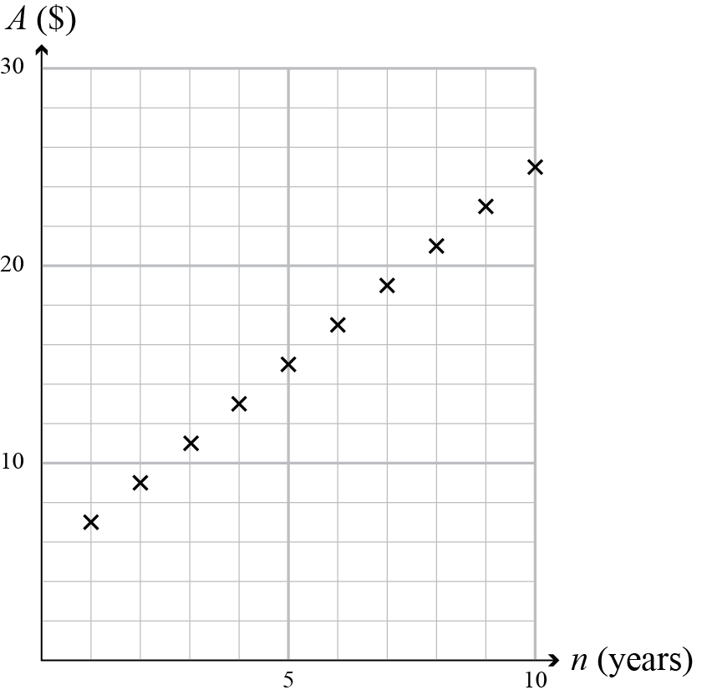 | Correct.  Accept with (0,5) included.  Accept with (0,0) included.
(iv) | From n = 4 graph increases.  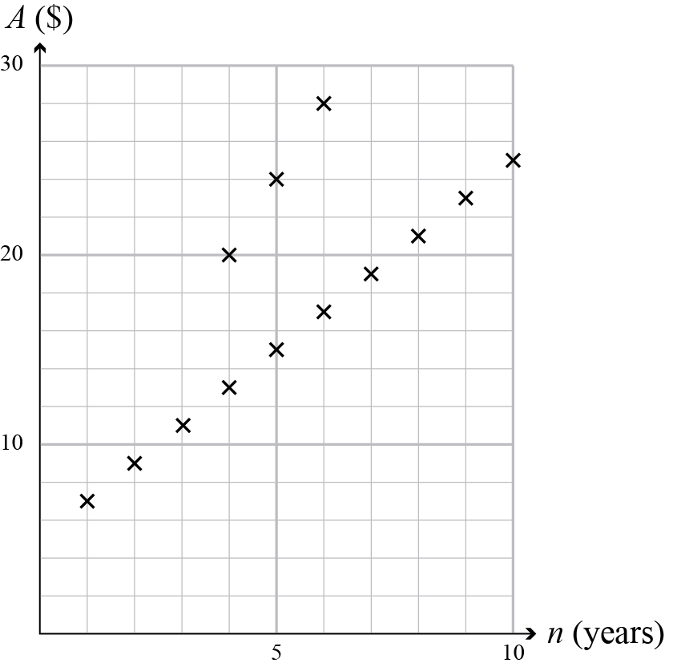 | Points plotted correctly  (4,20) (5,24) (6,28) with a line.  Accept from (3,16).  Accept step function. | Points plotted correctly  (4,20) (5,4) (6,28) without a line.  Accept from (3, 6).  Accept correct step function.
(v) | 4n + 4 = 44  n = 10  OR  44 = 4n + 16  to work out Arna’s age. | Appropriate equation(s) established  OR  CAO = 10 years. | Appropriate equation(s) established  AND  Number of years found.
(vi) | T = n² + 6n | Worked out 3 totals  ie: 7, 16, 27, .. .. |  | Correct equation.
(b) | y = ½ x(x – 3)  y = ½ x² – 1.5x  Accept consistent equation using (1.5,–1) as the vertex using a correct method. | 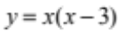 |  | Correct equation.
NØ no response, no relevant evidence.  N1 some evidence or 1 of u.  N2 2 of u. |  | A3 3 of u.  A4 4 of u. | M5 1 of r.  M6 2 of r. | E7 1 of t.  E8 2 of t.

Question | Evidence | Achievement | Achievement with Merit | Achievement with Excellence
TWO  (a)(i) | Graph of T = 20p  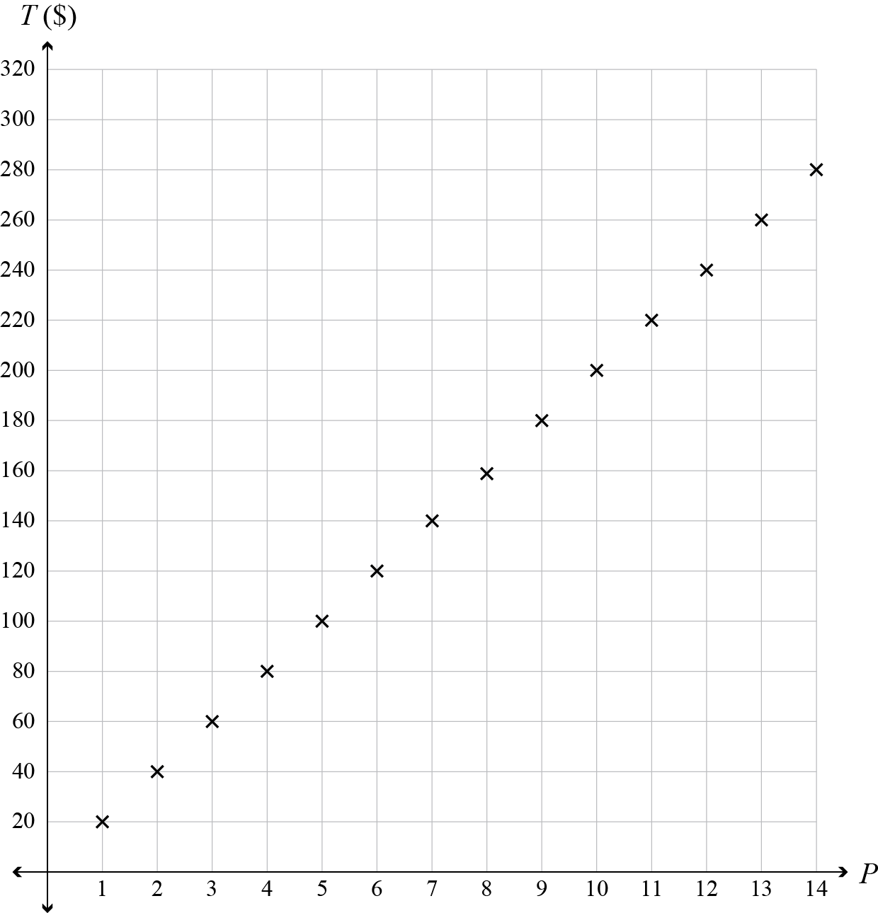 | Graph correct.  Accept line or step function.
(ii) | T = 20P | Correct equation.
(iii)  (iv) | Two points added to the graph.  (13,270) (14,300)  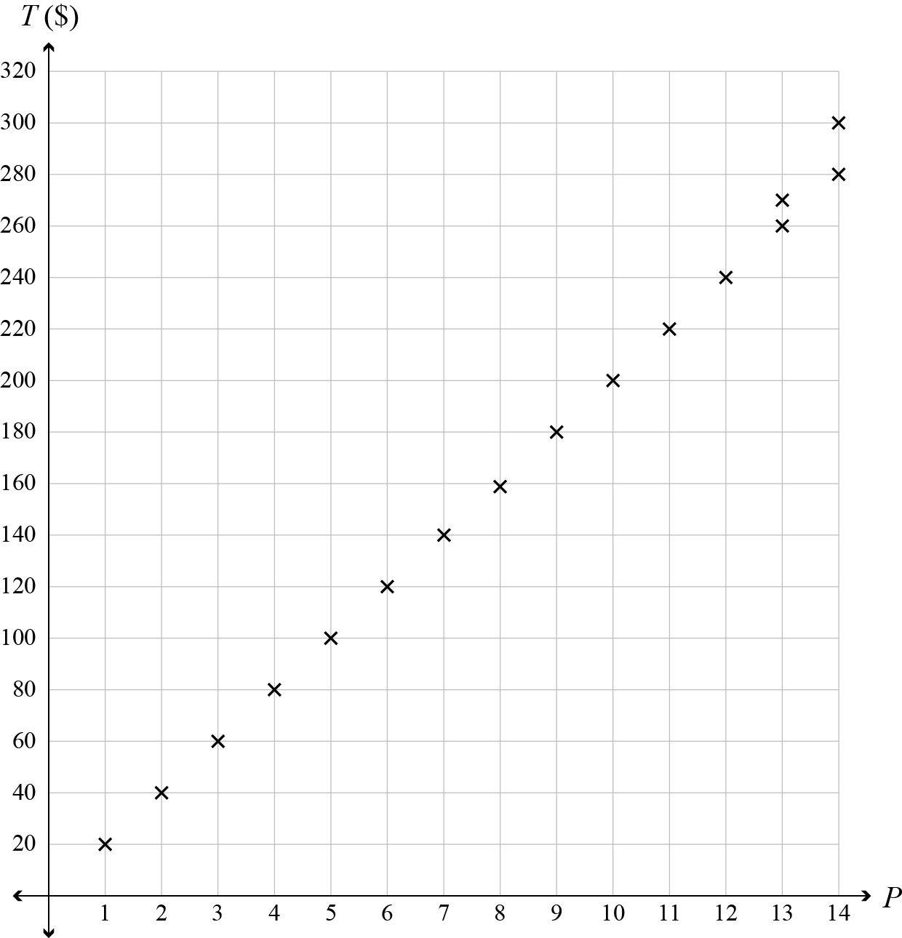  2 weeks | Graph correct.  OR  Correct value. | Graph correct.  AND  Correct value.
(v) | T = 30P – 120 | Gradient or intercept correct. |  | Correct equation.
(b)(i) | 3N + 6  4N + 6  4N + 12  N + 3  3 | Accept unsimplified.  Rest of 3rd column correct.
(b)(ii) | The starting number is multiplied by 3 and another added, giving 4 times the start number.  Dividing by 4 takes you back to the original number, which is then subtracted, leaving an answer of 0.  AND  The number added is 2, which when multiplied by 3 gives 6. Another 6 is added, giving 12, which when divided by 4, leaves an answer of 3. | ONE part partially described. | BOTH parts partially described.  OR  Used an algebraic equation to explain. | Full description given.
NØ no response, no relevant evidence.  N1 some evidence.  N2 1 of u. |  | A3 2 of u.  A4 3 of u. | M5 1 of r.  M6 2 of r. | E7 1 of t.  E8 2 of t.

Question | Evidence | Achievement | Achievement with Merit | Achievement with Excellence
THREE  (a)(i) | Graph drawn.  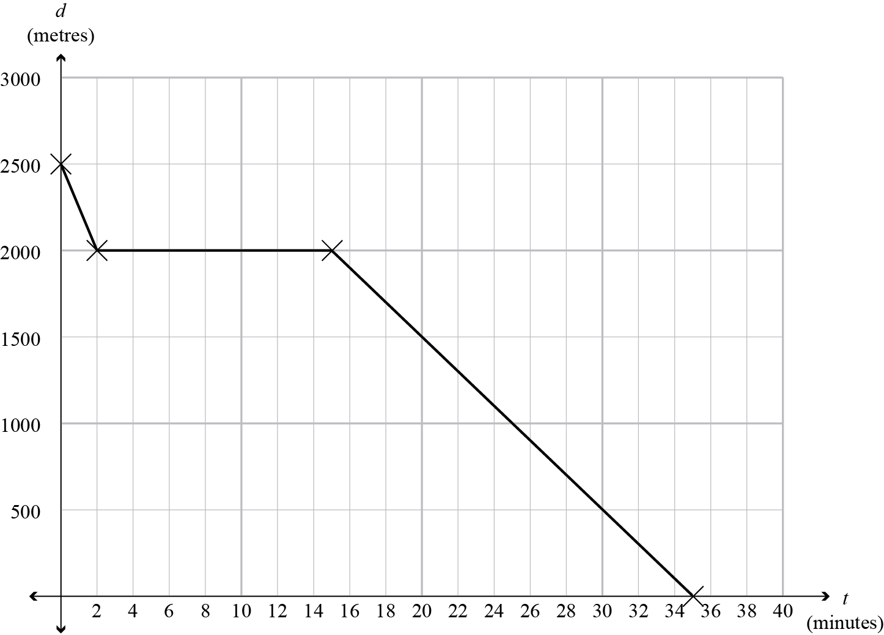 | 2 sections correct.  OR  4 points plotted correctly  (0,2500)  (15,2000)  (2,2000)  (35,0) | Graph correct.
(ii) | d = 2000  d = –100t + 3500 | Gradient or intercept correct. | ONE Equation correct. | BOTH  equations correct.
(b)(i) | Graph drawn.  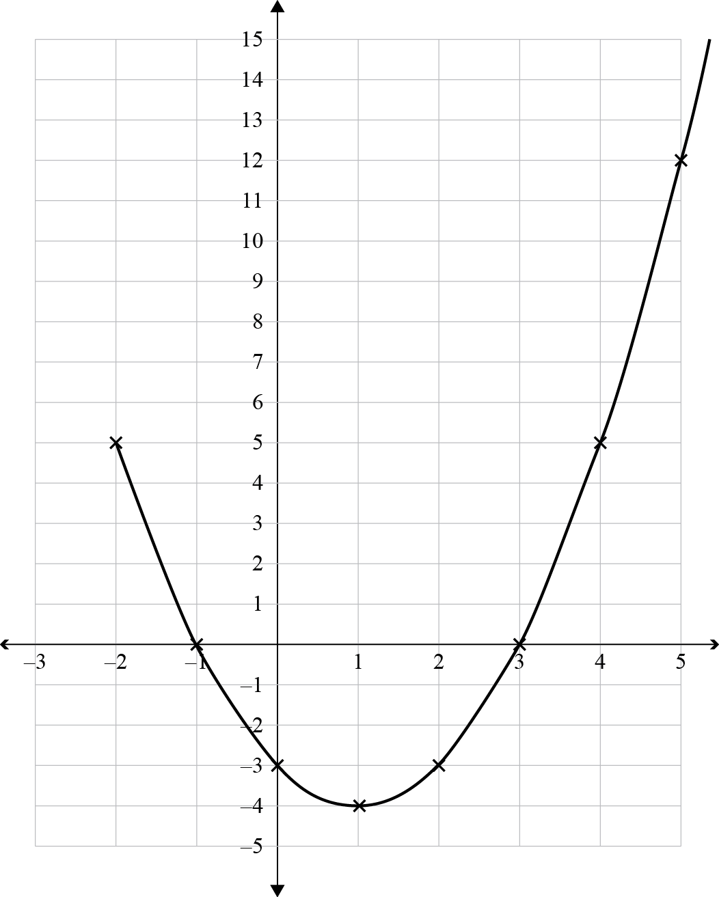 | Graph correct.  Accept points only.
(ii) | y = x² – 2x – 3  OR y = (x +1)(x - 3)  OR y = (x – 1)² – 4 |  | Correct equation.
(iii) | y = x² – 6x + 8  y = (x – 2)(x – 4)  y = (x – 3)² – 1  y = (x – 1)(x – 5) + 3  The graph is moved 2 places to the right and up 3. | Translation partially described.  OR  Identifies a new intercept correctly. | Full description of:  Changes to the graph. OR  Identifies all new intercepts correctly.  OR  Equation correct. | Full description of:  The translation of the graph.  OR  Identifies all new intercepts correctly.  AND  Equation correct..
NØ no response, no relevant evidence.  N1 some evidence.  N2 1 of u. |  | A3 2 of u.  A4 3 of u. | M5 2 of r.  M6 3 of r. | E7 1 of t.  E8 2 of t.

Judgement Statement
 | Not Achieved | Achievement | Achievement  with Merit | Achievement  with Excellence
Score range | 0 – 8 | 9 – 13 | 14 – 18 | 19 – 24

